
34th ANNUAL
“THE CLASSIC”
GLMGA INVITATIONAL TOURNAMENT

MEMBER EVENT PROGRAM
2026
November 5 – 7, 2026

GlenLakes Country Club  Weeki Wachee, Florida

Welcome — Member Registration
Dear Fellow Member,
On behalf of the GLMGA Invitational Golf Committee, it is my pleasure to welcome you to “The Classic” 2026 GLMGA Invitational Tournament. This year’s Invitational will begin Thursday, November 5th with 8:00 a.m. Registration followed by the First Round beginning at 10:00 a.m. The Invitational will conclude Saturday evening, November 7th with awards, dining and entertainment.
We are pleased to announce the entry fee will be $800 per team. Please see the Schedule of Events for all inclusions and additional information.
In an effort to expedite the billing & payment process, we are asking that a check or money order for $800 be dropped off or mailed to the Pro Shop prior to July 31st. Please make checks payable to GLMGA.
New for 2026 — Online Registration & Payment (optional):
You may now complete your registration online and/or pay online at https://glmga.org [link to be finalized]. These two options are independent — you may use one, both, or neither.
Online Payment: Pay your $800 entry online and only the exact card-processing fee is passed through to you — GLMGA adds nothing to it. Prefer no fee? Simply pay by check or money order as noted above, at no additional cost. Either way, GLMGA receives the full $800.
Online Registration: Complete the registration form on the website and your entry comes to us directly — no paper form needed. (Paper registration by drop-off, mail, or email remains available as always.)
Note: Please return your completed Registration Details (Entry Details & Guest Handicap Verification information, contained below) to the Pro Shop by July 31st or by email: dan.glenlakes@gmail.com or via US Mail or on the Website.
Cancellation Policy:
- If you cancel prior to September 15th, 2026, you will be refunded 75% of paid fees. You will not be eligible for participation gifts or meal functions.
- If you cancel on or after September 15th, 2026, the fees will not be refunded but you will receive participation gifts and can attend any meal function including Saturday evening.
The field will be limited to 48 teams, or eight flights of six teams.
Thank you for your participation in this memorable event. It continues to be a success because of your enthusiasm and commitment.
Sincerely,
Jim Silvera
Tournament Chairman

If you choose to use USPS, Mailing Address:
GlenLakes Pro Shop
Attn: Dan Benedetti
9000 GlenLakes Blvd.
Weeki Wachee, FL 34613

Tournament Specifics
Team Entry Includes
- All Green and Cart Fees. Practice round (available beginning October 1st).
- 5 nine-hole tournament rounds.
- Thursday registration, Dinner, and the “Players Par-Tee at the Pool” (Players only).
- Thursday, Friday and Saturday breakfast (Players only).
- Thursday, Friday grab-and-go lunch (Players only).
- Saturday: Awards Banquet and Dinner (jacket required, no tie).
- Gift Package for each member and guest.
- Hole-in-One and Closest-to-Pin prizes.
- Spouse / Ladies program on Friday, including the Ladies Luncheon.
- Flight Winner Trophies and Pro Shop Credit.
Format
- 5 nine-hole matches.
- 6 teams per flight.
- Team flights determined by combined handicap index.
- Each team will play a nine-hole match against each of the other five teams in the flight.
- Two matches on Thursday, two on Friday, and one match on Saturday.
- Points: 1 point for each hole won, 0.5 points for a halve, 0 points for a loss. Maximum of 6 points per match.
- Full handicap will be used, played off the low handicap in the foursome.
- Flight winners will be determined by total points won in the 5 matches.
- All nine holes will be completed on the side started.
Team Pairings: The order of nine-hole match play in each flight will be determined by draw and will be posted.
Ties: The winner of a tie for first place in a flight will be determined by the result of their head-to-head match, then a match of cards.
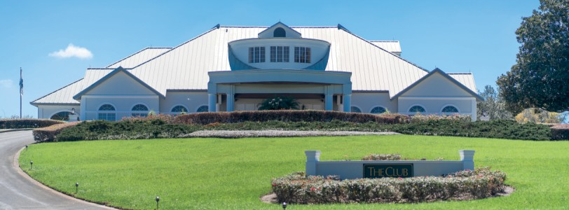

34th Annual “The Classic” · 2026 GLMGA Invitational Tournament
Schedule of Events
Practice Round is available beginning October 1st.
THURSDAY, NOVEMBER 5th
8:00 a.m. Registration and Breakfast (Pari-Mutuel Betting — Players Only)
10:00 a.m. First Round (Shotgun Start)
12:00 p.m. Grab-and-Go Lunch
1:00 p.m. Second Round (Shotgun Start)
5:00 p.m. Dinner — “Players Par-Tee at the Pool”
FRIDAY, NOVEMBER 6th
8:00 a.m. Breakfast Special (Players Only)
10:00 a.m. Third Round (Shotgun Start)
12:00 p.m. Grab-and-Go Lunch
1:00 p.m. Fourth Round (Shotgun Start)
3:00 p.m. Hors d’oeuvres, Beer Keg
3:30 p.m. Putting Contest
SATURDAY, NOVEMBER 7th
8:00 a.m. Breakfast Special (Players Only)
10:00 a.m. Fifth Round (Shotgun Start)
12:00 p.m. Beer Keg & Pari-Mutuel Shoot-Out Betting
1:00 p.m. Championship Shoot-Out (Everyone is welcome to attend)
5:30–7:30 p.m. Awards Cocktail Event
7:30–8:00 p.m. Awards Presentation
8:00–8:30 p.m. Night Cap Drinks and Desserts
Valet Parking Available
Suit or Sports Coat required for Gentlemen
SUNDAY, NOVEMBER 8th is the Rain Date.
For More Information Contact
Dan Benedetti, PGA Club Professional — GlenLakes Country Club
(352) 597-1118 · dan.glenlakes@gmail.com
Jim Silvera, Invitational Chairman
(352) 238-5934 · jim@silveraweb.com

Entry Details — 2026 | You may complete this online at https://glmga.org [link to be finalized]
“The Classic” — GlenLakes 2026 GLMGA Invitational Tournament
Please provide name, e-mail, and phone for all four people below. Spouse / significant-other contacts are used to share Ladies Luncheon details ahead of time.
Member:
Member’s E-Mail: | Member’s Phone:

Member’s Spouse / Significant Other:
Spouse / S.O. E-Mail: | Spouse / S.O. Phone:

Guest:
Guest’s E-Mail: | Guest’s Phone:

Guest’s Spouse / Significant Other:
Spouse / S.O. E-Mail: | Spouse / S.O. Phone:

Guest Address:
City: | State: | Zip:

Member Shirt Size: XXXL XXL XL L M (circle one)

Guest Shirt Size: XXXL XXL XL L M (circle one)
Member Tee: | Guest Tee: | Member Signature:

Guest Handicap Verification
“The Classic” — GlenLakes Men’s Invitational Tournament · Pro Shop: (352) 597-1118
Name:
Member Club:
Club Address:
City: |  | State: |  | Zip: |  |  | Phone:
Email Address: |  |  | I will be the guest of:
USGA Index: | Effective Date: |  |  |  |  | GHIN No.*:
Home Professional: |  |  | Club Name / State:
Phone: |  |  |  |  | Date:
* If no GHIN #, what handicap provider was used and contact information. / Home Club Tee Yardage
Please note: the Member must return fully completed form directly to:
The Pro Shop by July 31st, 2026 or by email: dan.glenlakes@gmail.com or via US Mail or on the Website.

Tournament Overall Winners
- Flight winners, including the 2nd-chance winner, will compete in a 3-hole alternate-shot shoot-out beginning on hole number 16.
Eligibility
Members
- Must be a member of the GLMGA with 10 posted scores.
Guests
- Must submit a USGA Handicap Index from his club along with a GHIN Number or contact for official verification. Maximum handicap permitted is 36.
Prizes
Trophies and Pro Shop certificates will be awarded. Cash Payout for Putting Contest.
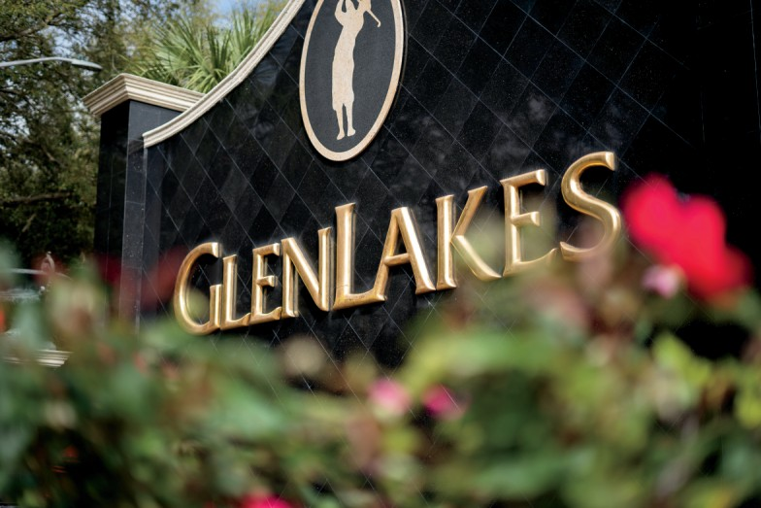
“Life that borders on the wild.”

